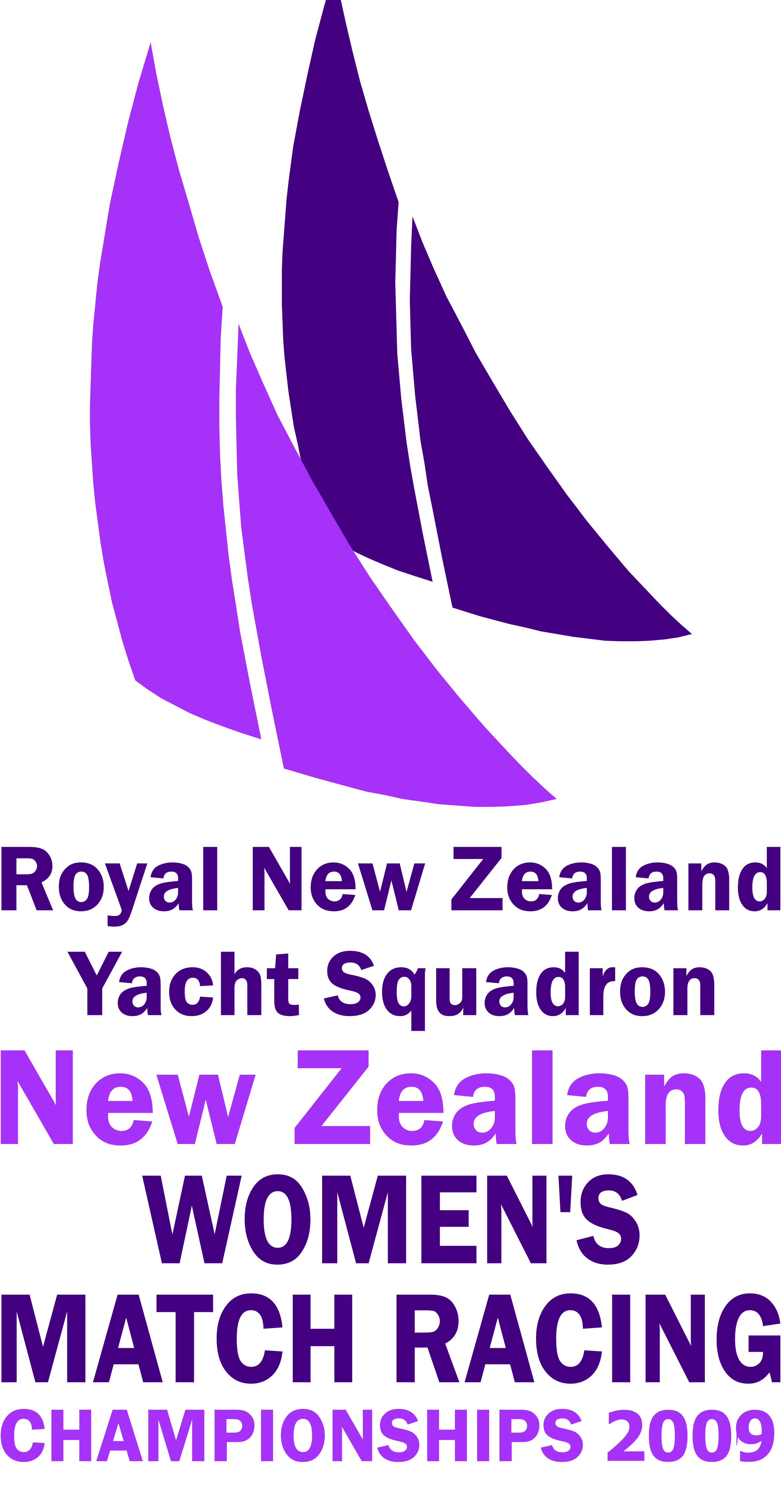
ROYAL NEW ZEALAND YACHT SQUADRON
New Zealand Women’s Match Racing Championships

26 – 29 March 2009

EXPRESSION OF INTEREST FORM

______________________________________________

HELMSPERSONS DETAILS

Helmspersons Name: ISAF Sailor ID Code:
Current ISAF Women’s Ranking: Dated:
Address:
Phone:
Mobile:
Email (preferred method of contact):
YACHT CLUB DETAILS
Name of Yacht Club:
Address:
Phone:
Fax:
Email:
Website:

CREW DETAILS
Helm:
Main:
Trimmer:
Bow:
Coach/Manager:

Please return to the RNZYS Sailing Office by Wednesday 30 January 2008
Email bdavies@rnzys.org.nz
Fax 360 6816

